**2.KOPS_Cluster_Creation**

---

**kops pre-requisites**

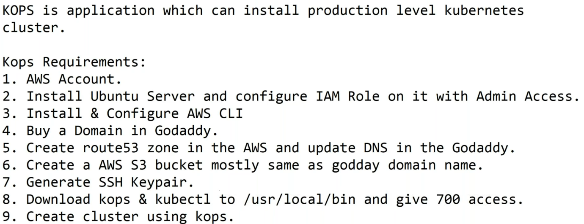

**Kops download**

--- **Reference** - <https://github.com/kubernetes/kops/releases/download/v1.24.0-alpha.5/kops-linux-amd64>

--- **sudo wget https://github.com/kubernetes/kops/releases/download/v1.24.0-alpha.5/kops-linux-amd64**

--- **sudo chmod 700 kops-linux-amd64**

--- **sudo mv kops-linux-amd64 kops**

--- **sudo mv kops /usr/local/bin**

**kubectl installation**

--- **Reference** - <https://kubernetes.io/docs/tasks/tools/install-kubectl-linux/>

--- **sudo curl -LO "https://dl.k8s.io/release/$(curl -L -s https://dl.k8s.io/release/stable.txt)/bin/linux/amd64/kubectl"**

--- **sudo chmod 700 kubectl**

--- **sudo mv kubectl /usr/local/bin**

**Cluster creating**

**# you want to try the dry run with kops**

--- kops create cluster --name=stacksimplify.club \

--state=s3://stacksimplify.club --zones=us-east-1a,us-east-1b,us-east-1c \

--node-count=3 --master-count=3 --node-size=t3.medium --master-size=t3.medium \

--master-zones=us-east-1a,us-east-1b,us-east-1c --master-volume-size 10 --node-volume-size 10 \

--dns-zone=stacksimplify.club --dry-run --output yaml

**# create a cluster using kops (this real time command)**

--- kops create cluster --name=stacksimplify.club \

--state=s3://stacksimplify.club --zones=us-east-1a,us-east-1b,us-east-1c \

--node-count=3 --master-count=3 --node-size=t3.medium --master-size=t3.medium \

--master-zones=us-east-1a,us-east-1b,us-east-1c --master-volume-size 10 --node-volume-size 10 \

--dns-zone=stacksimplify.club –yes

**# create a cluster using kops (practice kops cluster command)**

--- kops create cluster --name=stacksimplify.club \

--state=s3://stacksimplify.club --zones=us-east-1a,us-east-1b,us-east-1c \

--node-count=2 --master-count=1 --node-size=t3.medium --master-size=t3.medium \

--master-zones=us-east-1a --master-volume-size 10 --node-volume-size 10 \

--dns-zone=stacksimplify.club --yes

**# validate cluster**

--- kops validate cluster

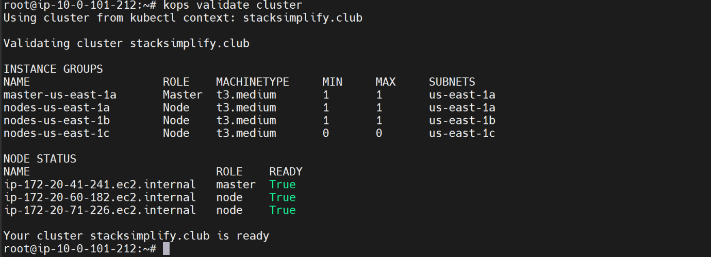

**# List the cluster**

--- kops get cluster

**# Delete the cluster**

--- kops delete cluster stacksimplify.club

**Cluster information**

**# List cluster information**

--- kubectl cluster-info

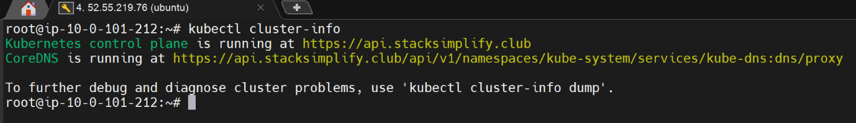

**Add additional nodes to cluster using kops**

--- **scenario** – you are tasked to add additional nodes to cluster then

**# List instance group or worker nodes.**

--- kops get ig

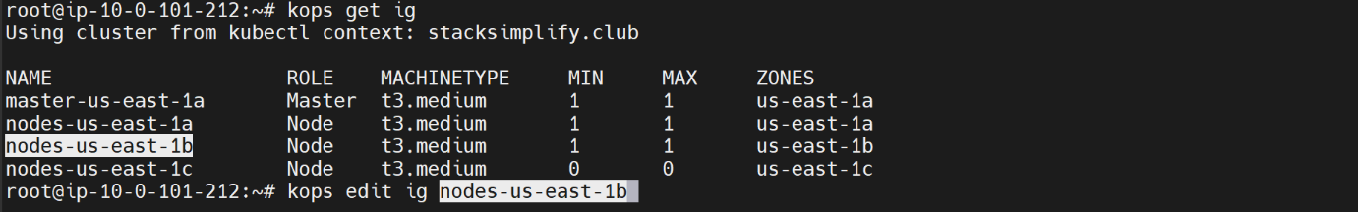

**# Edit the instance group.**

--- kops edit ig nodes-us-east-1b

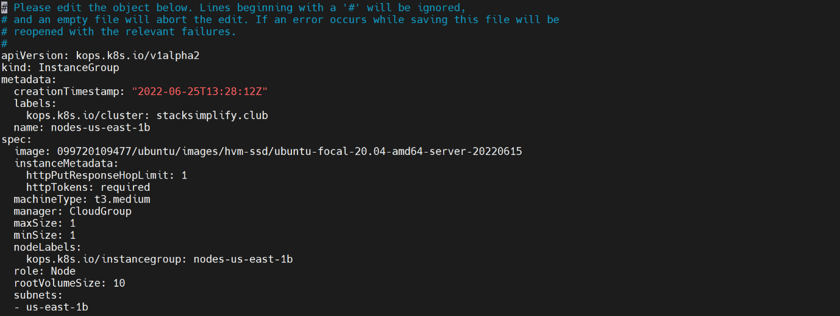

--- **note** – if you give maxSize and minSize is 2 then it will increase by 1.

**Node groups**

**# List the nodes**

--- Kubetctl get nodes -o yml

**PODS**

**# List all pods**

--- kubectl get pods -A

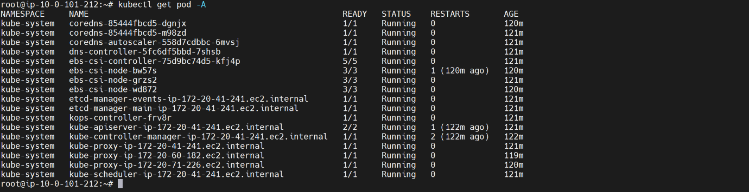

**# List the pods in a name space.**

--- kubectl get pods -n kube-system

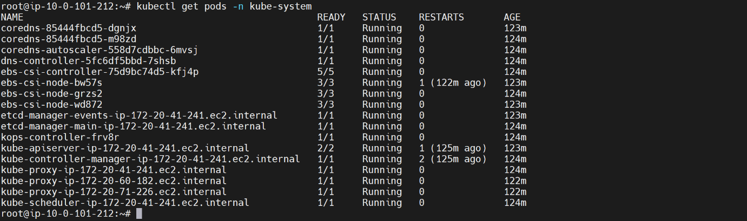

**Service**

**# List service**

--- kubectl get svc

**Cluster Smoke Testing**

**# List the kubectl version**

--- kubectl version –short

**# List the nodes**

--- kubectl get nodes

**# List the cluster information**

--- kubectl cluster-info

**# List the name space**

--- kubectl get ns

**# List the pods**

--- kubectl get pods

**# List the pods in kube-system name space**

--- kubectl get pods -n kube-system

**# List all the services**

--- kubectl get service -A

**# create pods**

--- kubectl run deploy01 --image=sreeharshav/rollingupdate:v5

**# Expose pods with NodePort service.**

--- kubectl expose pod deploy01 --port=8000 --target-port=80 --type=NodePort

**# List the pods**

--- kubectl get pods -o wide

--- kubectl get pods -o wide --no-headers